Image | 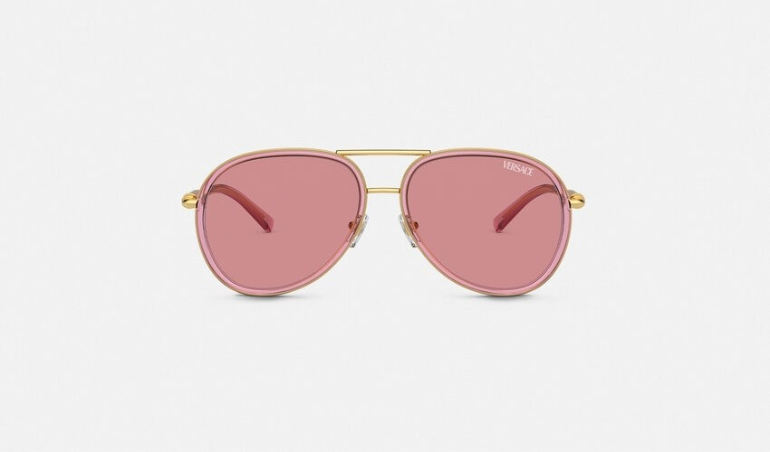
Brand | TOM FORD
Model Name | MEDUSA ROLLER PILOT SUNGLASSES
Price | RS 160,400
PRODUCT DETAILS

